Title or Task: | Flash Fades

Description:

Files Required

Suitable for Classes:
Area: | Technology & Enterprise
Teacher: | Mr Peter Faulks

Timeline

Date Due:

Task Brief:

Outcomes:

Items highlighted in yellow are tasks for you to complete
Items in Blue italics are help tips



These pages are designed to show you how to use software packages; various software updates may have taken place so some pages will not apply to versions other than those listed here. In some cases data files may be required.

Flash Text Effect Tutorial - Fades
Fades can be primarily be of three types
- Fade-in Effect: Object gradually comes into view.
- Fade-out: Object is visible at the start and then vanishes.
- Object fades in and out over time.
In Flash, you can apply all the three effects to objects. However, these objects must be first converted to symbols. Fading is accomplished by modifying the visibility of symbols instances using the Alpha color effect. Sounds confusing? It's actually quite simple.
Step 1
Open a new file. Change the layer name to something more descriptive as "Fade effect".
Step 2
With the first frame highlighted, create a rectangle using the Rectangle tool . Now convert this object to a symbol by first selecting it with the Arrow tool and then clicking on Insert - Convert to Symbol. When asked for a symbol name, type "rect" (without the quotes) and make sure that the Behavior for this symbol is set to Graphic.
Step 3
Align this symbol to the center of the page. An easy way to do this is through Align command in the Modify menu. In the align window, (shown below) click on the icons in both vertical and horizontal alignments and check the Align to Page checkbox.
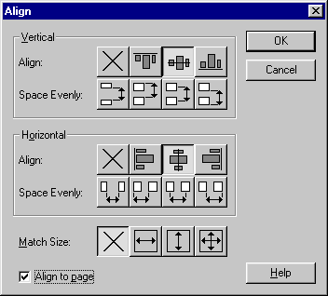
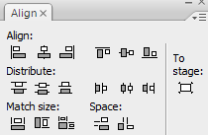
Step 4
Add a keyframe at frame 36.
And with frame 36 highlighted on the time line, click on Modify - Instance. The Instance Properties window opens up. Click the Color Effect tab and select Alpha from the drop down menu. Change the Alpha value to 0% (you can do this by either typing the value in the text field or moving the slider to the extreme left).
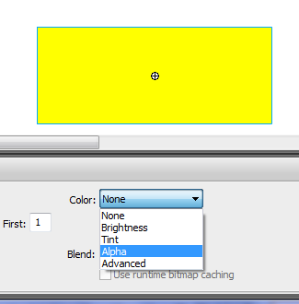
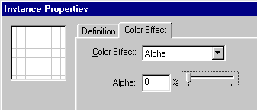
So what have we done here? By adding a keyframe at frame 36, we create an Instance of our symbol rect. The properties of this instance can then be changed through the Instance properties window. In addition to Alpha, there are other properties like, Brightness, Tint and Special. Alpha changes the transparency of the symbol. Thus, 100% alpha signifies that the object is fully visible while 0% makes it completely transparent.
STEP 5
You shall notice that the symbol has vanished though the selection outline is still visible.
The last step is to apply a motion tween between the start and end frames.
Right-click on a middle frame, and select Create Motion Tween from the drop down menu.
You have just created a fade-out effect. Click Control - Play to see your result.



